**SRI VENKATESHWARA UNIVERSITY-TIRUPATI**

**A MINOR PROJECT REPORT**

ON

**EMPLOYEE LEAVE MANAGEMENT SYSTEM**

Submitted in partial fulfillment of the requirements for the IIIrd Semester of

**MASTER OF COMPUTER APPLICATIONS**



Submitted

By

**A. USHA (2724180)**

**D.VAMSI KRISHNA (2724181)**

**A.K. VIKRAM (2724187)**

Under the valuable Guidance of

**A. Murali Mohan Kumar MCA, HSM, GNIIT**

**ASSOSIATE PROFFESSOR**



**MOTHER THERESA INSTITUTE OF COMPUTER APPLICATIONS**

(Affiliated to S. V. University, Tirupati)

**PALAMANER-517408. CHITTOOR DIST. (A.P)**

**2024-2026**

**MOTHER THERESA INSTITUTE OF COMPUTER APPLICATIONS**

**DEPARTMENT OF MCA**

(AFFILIATED TO S.V University, Tirupathi)

**PALAMANER – 517408**

**2024-2026**

 **CERTIFICATE**

This is to certify that the Project entitled **TRAVEL BOOKING SYSTEM** is the confined record work done by **A. USHA (2724180), D. VAMSI KRISHNA (2724181)** and **A.K. VIKRAM (2724187)** in partial fulfillment of the requirement for the award of Master of Computer Applications in Sri Venkateswara University, Tirupathi (AP).

**Internal Guide Head of the department**

**External Examiners**

**1.**

**2.**

**DECLARATION**

**W**e hereby declare that the project work entitled **TRAVEL BOOKING SYSTEM** done for Mother Theresa Institute of Computer Applications is submitted in partial fulfillment of the requirements for the award of the degree of Master of Computer Applications and it is a report of the original work done by me and our team under the guidance of Associate Prof. **Mr. A. Murali Mohan** during the period of **Oct– Dec** 2025 in College Lab of Mother Theresa Institute of Computer Applications.

**Signature of the Student**

1.

2.

3.

**ACKNOWLEDGEMENT**

Firstly, I would like to express our immense gratitude towards our institution **Mother Theresa Institute of Computer Applications**, which created a great platform to attain profound technical skills in the field of Application Development, thereby fulfilling our most cherished goal.

I would thank all the **Department of MCA** of Mother Theresa Institute of Computer Applications and the Staff for guiding and helping me in successful completion of the project

I sincerely express my gratitude to the Director **Dr. N. RAJA KUMAR** and for his inspiration and timely support in successful completion of my project work.

I am very much thankful to Principal/Head of the Department **Mr. R. Prabhakar Naidu** for extending his guidance and cooperation in doing this project.

I am also thankful to our Project Guide **Mr. A. Murali Mohan Kumar**, for extending his Cooperation and guidance in completion of Project.

I convey my thanks to my beloved **parents, friends, faculty and my Lab Administrator** who helped me directly or indirectly in bringing this project successfully.

|  |  |  |
| --- | --- | --- |
| **Sl. No** | **Contents** | **Page Numbers** |
| 1. | Overview and Introduction | 01-02 |
| 2. | Existing System | 03 |
| 3. | Proposed System | 04 |
| 4. | Process Models | 04-08 |
| 5. | Hardware and Software Requirements   1. Hardware Requirements 2. Software Requirements | 09-11 |
| 6. | Feasibility Study   1. Technical Feasibility 2. Operational Feasibility 3. Economic Feasibility | 12-13 |
| 7. | Module Description | 14-17 |
| 8. | System Design and Flow Analysis   1. UML Diagrams 2. DFDs | 18-26 |
| 9. | Database Design   1. Database Dictionary 2. SQL Code | 27-31 |

**TABLE OF CONTENTS**

**Abstract**

The **Travel Booking System** is a standalone desktop-based software application designed to automate and simplify the process of planning, managing, and booking travel-related services such as holiday packages, destinations, and customer details. The system is implemented using **Python (Django Framework)** for backend processing, **HTML and CSS** for interface design, and **Oracle 11g** as the database management system. It operates independently on a single machine running Windows 10 Professional, ensuring complete functionality without the need for any external web server or internet dependency. This project is developed under the assumption that all transactions and operations will be handled within a controlled local environment, typically suitable for travel agencies, educational project demonstrations, or small-scale tourism firms.

The system is designed to ensure accuracy, consistency, and reliability of stored data. Oracle 11g serves as the backbone of the database, maintaining all customer, package, and booking details in a structured relational format. Data is stored with constraints, keys, and relationships to preserve data integrity and eliminate redundancy. The application’s front-end interface is created with HTML and CSS for simplicity and clarity, allowing users and administrators to navigate easily through different modules. The Django framework manages the control flow between the user interface and database operations, ensuring a seamless and secure execution of CRUD (Create, Read, Update, Delete) processes.

This project follows the Waterfall Model of the Software Development Life Cycle (SDLC). Each development phase—requirement analysis, system design, implementation, testing, deployment, and maintenance—is executed sequentially. This model was chosen due to its structured and predictable nature, making it ideal for standalone applications where requirements are well-defined and unlikely to change frequently. The use of the Waterfall model ensures systematic progress, proper documentation, and complete verification before proceeding to subsequent stages, thereby minimizing development risks and ensuring project stability.

Functionally, the Travel Booking System includes key modules such as User Login and Registration, Package Management, Booking and Payment Processing, and Administrative Control.

* The User Module allows customers to register, log in, and browse available travel packages.
* The Package Module enables administrators to add, modify, or delete packages as per demand or availability.
* The Booking Module manages the booking of packages, storing details of customers, travel dates, and total costs.
* The Admin Module allows system administrators to oversee system activities, maintain customer records, and generate reports for analysis.

Each module is designed to function independently while maintaining integration through shared data in the Oracle 11g database.

One of the major strengths of the proposed standalone Travel Booking System lies in its offline capability. The absence of web server dependency ensures that the system can function smoothly even in locations with limited internet connectivity. This makes it highly suitable for regional travel agencies, institutional environments, or small organizations where the priority is efficient local management rather than online scalability. Additionally, the standalone design enhances security, as all user credentials and booking data remain confined within the local database.

From an operational perspective, the system enhances performance, reduces redundancy, and saves time for both users and administrators. It minimizes manual intervention, thereby reducing the probability of human errors. The user interface is simple and intuitive, catering to both technical and non-technical users. The project also emphasizes data validation and error handling to ensure the accuracy and completeness of information entered into the system.

In conclusion, the Travel Booking System represents an effective, efficient, and secure approach to managing travel bookings through a desktop-based solution. It fulfills the modern need for automation, offering convenience, accuracy, and flexibility in handling travel operations. Its design ensures ease of use, reliability, and maintainability, aligning perfectly with small-to-medium-scale travel management requirements. With a robust architecture based on the Waterfall Model, strong Oracle database support, and a clean Django-based interface, this project stands as a reliable model for implementing professional travel management in an offline environment.

**TRAVEL BOOKING SYSTEM**

**1. OVERVIEW**

**1.1 Introduction**

The **Travel Booking System** is a web-based project designed to streamline and automate the travel booking process for users and agencies. The project aims to address the limitations of traditional booking methods by offering a centralized digital platform for flights, trains, buses, cabs, and tour packages. It ensures efficiency, transparency, and accessibility while maintaining security and reliability in every booking transaction.

Travel agencies and customers often face challenges such as limited communication, manual booking processes, delays in confirmation, and errors in seat allocation. This case study explores how the proposed Travel Booking System overcomes these challenges through modern web technologies.

**1.2 Background and Problem Identification**

Traditional travel booking systems are largely manual or semi-automated. Customers rely on agents to check availability and book tickets. This process is time-consuming and prone to human errors. Agents may double-book seats or face synchronization issues with different transportation providers. In addition, generating reports or tracking historical data manually is inefficient.

The increasing demand for quick, reliable, and accessible online booking platforms necessitates an automated system that integrates all travel services under one roof. The proposed Travel Booking System focuses on creating a responsive and robust digital platform to manage travel operations effectively.

**1.3 Objectives**

The main objectives of the Travel Booking System are:

* To provide an integrated online platform for travel booking.
* To automate the process of searching, booking, and managing travel services.
* To maintain accurate data records for customers, agents, and administrators.
* To generate electronic tickets and digital receipts for bookings.
* To offer real-time seat availability and pricing details.
* To minimize manual effort, improve accuracy, and enhance user experience.

**1.4 Scope**

The project covers the management of multiple types of travel services such as flights, buses, trains, cabs, and tour packages. The system supports multiple roles: **Customer**, **Agent**, and **Administrator**, each with specific functionalities. It also includes modules for bookings, payments, notifications, and reporting.

The system does not connect to live external APIs in this academic prototype but simulates real-world behavior using mock data for demonstration.

**1.5 Stakeholders**

* **Customers:** End users who search for and book travel services.
* **Agents:** Responsible for handling customer bookings and service management.
* **Administrators:** Manage the database, monitor system performance, and handle user permissions.
* **Developers:** Maintain and upgrade the system.

**1.6 Expected Outcomes**

By implementing this system, users can:

* Access travel services 24/7 from any device.
* Make secure payments and receive instant booking confirmations.
* Track booking history and request cancellations or refunds easily.

Administrators will benefit from detailed reports, performance monitoring, and user management tools. Overall, the Travel Booking System will enhance efficiency and accuracy across all operations.

**1.7 Benefits**

* Simplifies booking operations for users and agents.
* Reduces the workload and manual effort of travel agencies.
* Ensures secure and verified transactions.
* Provides centralized management of data.
* Improves customer satisfaction and operational productivity.

**1.8 Limitations**

* Internet connectivity is required for accessing the system.
* Integration with live airline and railway APIs is not included in the current version.
* Payment gateway functionality is simulated for academic use.

**2. EXISTING SYSTEM**

The existing travel booking systems in many small and mid-level agencies are outdated and rely on manual or semi-automated workflows. Bookings are often made over phone calls, emails, or through third-party websites that do not synchronize with agency records. This results in several limitations:

**3.1 Limitations of the Existing System**

* **Manual Processes**: Most bookings and cancellations are handled manually, leading to inefficiencies.
* **Data Inconsistency:** Information is scattered across multiple files and records, leading to duplication.
* **Lack of Real-Time Availability**: Seat or room availability may not be updated immediately, causing booking conflicts.
* **Limited Accessibility**: Customers must rely on agents for booking and cannot directly access availability data.
* **Inadequate Reporting**: Manual systems make it difficult to generate timely sales and performance reports.
* **High Error Rate**: Manual data entry increases the risk of mistakes and inconsistencies.

The absence of a unified online system restricts business growth and causes poor customer satisfaction.

**3.2 System Impact and Future Enhancements**

The implementation of the proposed standalone **Travel Booking System** will significantly transform the traditional workflow of travel management agencies. By integrating all core operations—such as booking management, package maintenance, and customer data handling—into a single automated platform, the system ensures streamlined operations and reduced dependency on manual intervention. The offline capability of the system, running entirely on **Windows 10 Pro with Oracle 11g**, makes it especially valuable for small and mid-level agencies that lack continuous internet access or advanced IT infrastructure. Furthermore, this system can be easily extended in the future to include advanced features such as **dynamic pricing models**, **AI-based travel recommendations**, **automated report generation**, and **integration with third-party APIs** for transport or accommodation services. Overall, the system not only enhances accuracy, speed, and efficiency in travel operations but also provides a scalable foundation for future digital transformation within the travel domain.

**3. PROPOSED SYSTEM**

The proposed Travel Booking System addresses the shortcomings of the existing setup by offering a centralized, automated, and web-based solution. This system is designed to handle all aspects of travel booking — from searching and selecting services to payment and ticket generation.

**4.1 Features of the Proposed System**

1. **Centralized Database**: Oracle 11g stores all travel data in a structured and secure manner.
2. **User Authentication**: Django manages secure user login, session management, and password protection.
3. **Real-Time Booking**: The system automatically updates seat and ticket availability after every transaction.
4. **Automated Payment Handling**: Integrates with simulated payment gateways for smooth processing.
5. **Modular Access Control**: Different roles (Customer, Agent, Admin) with specific permissions.
6. **Reporting and Analytics**: Real-time generation of booking, sales, and cancellation reports.
7. **E-Ticket and QR Code**: Instant ticket generation with unique identifiers for verification.
8. **Notification System**: Automated email and SMS alerts for confirmations and cancellations.

**4.2 Advantages of the Proposed System**

* Reduces manual workload and data redundancy.
* Improves operational efficiency and transparency.
* Offers real-time updates and error-free transactions.
* Enhances customer satisfaction through quick service.
* Allows scalability and future integration with APIs.

**4.3 Expected Results**

* A fully functional travel booking platform with user and admin dashboards.
* Seamless booking flow with electronic confirmation.
* Reduction in operational cost and time.
* Improved record management and reporting capabilities.

**5. PROCESS MODEL**

**Chosen Model: Waterfall Model**

**5.1 Introduction**

In software engineering, a process model defines the structured approach followed during the development life cycle of a project. The process model ensures that all development phases are executed in a planned, sequential, and traceable manner. For the Travel Booking System, a standalone application built on Django Framework, with HTML, CSS, and Oracle 11g, the Waterfall Model is the most suitable approach.

The system’s requirements are well-defined, stable, and unlikely to change frequently. It does not depend on complex user interactions or external API integrations beyond a basic payment gateway simulation. This makes the Waterfall Model ideal because it is linear, disciplined, and ensures that every phase is completed before moving to the next.

**5.2 Overview of the Waterfall Model**

The Waterfall Model is a sequential software development process that progresses through well-defined stages — each dependent on the completion of the previous one. The stages flow downwards like a waterfall, hence the name. It emphasizes documentation, validation, and verification at each step.

The six main phases of the Waterfall Model are:

1. Requirement Analysis
2. System Design
3. Implementation (Coding)
4. Testing
5. Deployment
6. Maintenance

Each stage has specific deliverables and review processes, making it easy to track progress and maintain quality standards.

This is how WaterFall Model can be represented in Pictorial way:

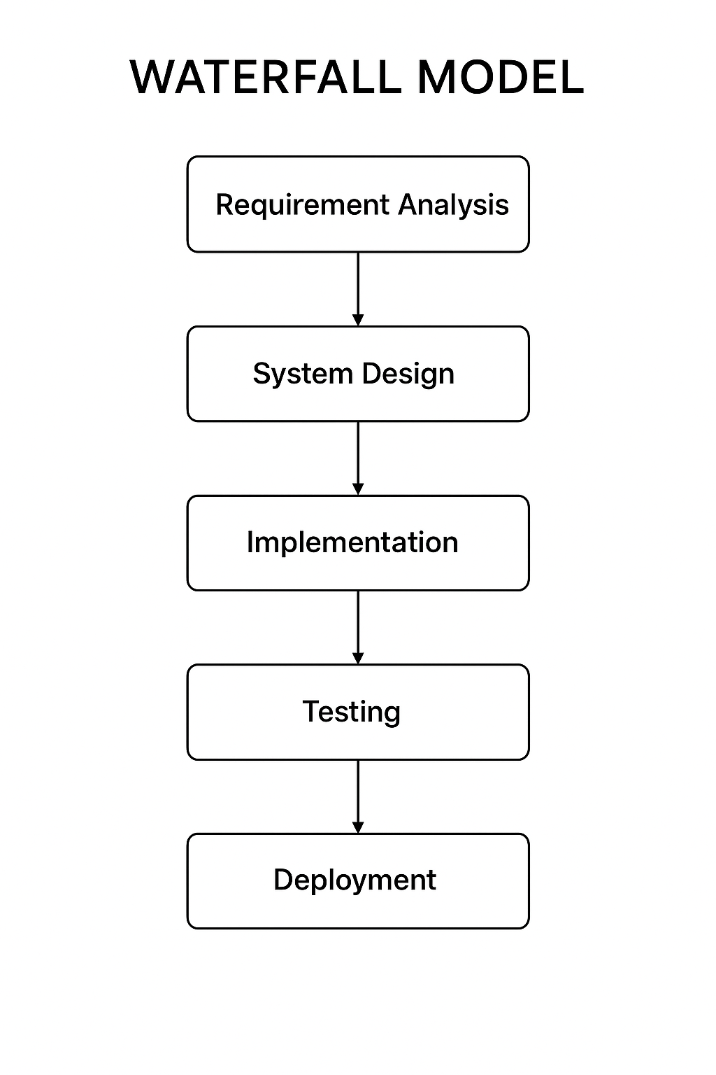

**5.3 Why the Waterfall Model Suits the Travel Booking System**

**a) Stable and Clearly Defined Requirements**

The Travel Booking System’s requirements — such as user registration, package management, booking, and payment — are stable and do not require iterative user feedback for refinement. This makes a linear model more efficient than an agile or spiral model, which would add unnecessary complexity.

**b) Sequential Nature of the Application**

This project follows a straightforward sequence:

* Collect requirements
* Design system architecture and database
* Develop frontend (HTML/CSS) and backend (Django + Oracle)
* Test functionality
* Deploy and use on standalone machines

This aligns perfectly with the phase-by-phase approach of the Waterfall Model.

**c) Low Risk and Predictable Development**

As a standalone project, it does not rely on external dependencies such as live web services or multiple third-party APIs. Therefore, risk factors are minimal, and development can proceed with full predictability — a key strength of the Waterfall approach.

**d) Documentation-Driven Development**

Academic and professional projects often require well-documented deliverables at every phase. The Waterfall Model enforces this discipline by requiring clear documentation for requirements, design, implementation, and testing. This helps in maintaining clarity for project evaluation and future maintenance.

**e) Easier Management and Review**

Each stage in the Waterfall Model produces specific outputs that can be reviewed before moving forward. This makes project tracking simpler for both developers and supervisors. Since the Travel Booking System is handled by a small development team or a single student, this model provides better control over progress and quality.

**5.4 Application of Waterfall Phases to This Project**

|  |  |
| --- | --- |
| **Phase** | Description and Application in Travel Booking System |
| **Requirement Analysis** | Gathered information about travel packages, booking flow, admin functions, and database needs. Defined user roles, data constraints, and security needs. |
| **System Design** | Designed UML diagrams, ER diagram, database schema, and interface wireframes. Established data flow between user, admin, and database modules. |
| **Implementation** | Developed the system using Django (Python) for backend logic, HTML/CSS for frontend, and Oracle 11g for data management. |
| **Testing** | Performed unit testing, module testing, and integration testing to ensure smooth booking, payment, and data retrieval functionalities. |
| **Deployment** | Installed the standalone application on Windows 10 Pro systems. Linked Django with Oracle using appropriate connectors. |
| **Maintenance** | After deployment, any discovered bugs or enhancements are fixed in this phase. Future versions can include new features such as real-time APIs for hotel or flight booking. |

**5.6. Tools Used**

* **Operating System:** Windows 10 Pro
* **Backend:** Django (Python Framework)
* **Database:** Oracle 11g
* **Frontend:** HTML, CSS, JavaScript
* **IDE:** Visual Studio Code / PyCharm
* **Browser:** Google Chrome
* **Design Tools:** StarUML / Draw.io for UML diagrams
* **Testing Tools:** PyTest, Django Testing Framework

**5. HARDWARE AND SOFTWARE REQUIREMENTS**

**(A)HARDWARE REQUIREMENTS**

The hardware configuration plays a vital role in ensuring smooth operation of the standalone application. The configuration has been selected to balance cost efficiency with system performance.

**a) Processor (CPU)**

A multi-core processor such as Intel Core i5 or AMD Ryzen 5 is required to handle the concurrent operations of Django, Oracle 11g, and background processes efficiently.  
It ensures smooth execution of local queries, faster response time, and reliable multitasking during development and testing.

**b) Memory (RAM)**

A minimum of 8 GB RAM is recommended.  
Since the Travel Booking System runs Django (Python interpreter), Oracle database, and development tools simultaneously, sufficient memory allocation is necessary to avoid lag and enhance overall performance.

**c) Storage Device**

A 500 GB Hard Disk Drive (HDD) or a 256 GB Solid-State Drive (SSD) is required to store all essential data, including database files, application modules, and user information.  
SSD storage is preferred as it provides faster data retrieval and reduces loading times during booking or reporting processes.

**d)Monitor / Display**

A 15-inch or higher monitor with a resolution of at least 1366 × 768 pixels is recommended to display the application’s interface clearly.  
This resolution ensures comfortable viewing of travel packages, booking forms, and **administrative reports.**

**e) Input Devices**

A standard keyboard and optical mouse are necessary for user input, data entry, and system navigation.  
These input devices support all administrative and customer-side operations within the system.

**f) Graphics Support**

Integrated graphics are sufficient for rendering the GUI components designed using HTML and CSS.  
However, systems with at least 1 GB video memory (VRAM) are recommended for smoother visual rendering.

**g) Network Adapter (Optional)**

Although the Travel Booking System is a standalone application, an Ethernet or Wi-Fi adapter can be used if optional features like system updates or online payment gateways are later integrated.

**h) Backup Device**

An external storage device such as a 32 GB USB drive or external hard disk should be available for routine backup of the Oracle database.  
This ensures data recovery in case of system failure or corruption.

**i) Operating System**

The recommended operating system is Windows 10 Professional (64-bit).  
It provides compatibility with Django, Python, and Oracle 11g, along with a stable environment for development and execution of the application.

**(B) SOFTWARE REQUIREMENTS**

**a) Operating System**

The system runs on Windows 10 Pro (64-bit), which offers high stability, performance, and full support for Python and Oracle environments.  
It also provides the necessary command-line utilities and file handling capabilities required for Django-based standalone development.

**b) Front-End Technologies**

The front-end of the Travel Booking System is developed using HTML and CSS.  
HTML is used for structuring the pages such as login, package display, and booking forms, while CSS provides consistent styling and formatting for a professional user interface.

**c) Programming Language**

The main programming language used is Python (Version 3.10 or higher).  
Python is selected due to its simplicity, rich library support, and integration with the Django framework.  
It handles business logic, validation, and communication with the Oracle database.

**d) Framework**

The Django Framework (Python-based) is used to implement the application logic following the Model-View-Controller (MVC) pattern.  
It manages user requests, handles backend operations, and processes data transactions with Oracle.  
The framework runs locally without the need for an external web server, utilizing the internal Django development server for testing and execution.

**e) Database Management System**

The project uses Oracle 11g as its database management system.  
Oracle provides reliable storage and retrieval of travel packages, user details, booking records, and payment information.  
It supports high data integrity and ACID compliance, ensuring that all transactions are processed accurately and securely.

**f) Database Management Tools**

Oracle SQL Developer is used as the graphical interface for database creation, schema design, query execution, and maintenance tasks.  
It assists in performing CRUD (Create, Read, Update, Delete) operations efficiently within Oracle 11g.

**g) Database Connector**

The cx_Oracle Python library serves as a bridge between Django and Oracle 11g.  
It allows Django ORM (Object Relational Mapper) to communicate directly with the Oracle database for query execution and data synchronization.

**h) Development Environment / IDE**

For writing and debugging code, tools such as Visual Studio Code or PyCharm Community Edition are recommended.  
These IDEs support Python syntax highlighting, version control, and terminal integration, enhancing the overall development workflow.

**System Configuration Overview**

* **System Type:** Standalone (Localhost-based Application)
* **Deployment Environment:** Windows 10 Pro
* **Backend Database:** Oracle 11g
* **Framework:** Django MVC Architecture
* **User Interfaces:** Admin Panel, Customer Portal, Agent Module
* **Connectivity:** No external internet dependency — runs fully offline except for SMTP/email simulation
* **Execution Command:**

python manage.py runserver

* 1. **FEASIBILITY STUDY**

## **Feasibility Study Report**

A feasibility study evaluates whether the proposed **Travel Booking System** is practical, achievable, and cost-effective within the given technical, operational, and economic constraints.  
This section analyzes the **Technical Feasibility**, **Operational Feasibility**, and **Economic Feasibility** of the system to ensure successful implementation.

### **(A) Technical Feasibility**

**Definition:**  
Technical feasibility examines whether the technology, tools, and technical expertise required for developing the system are available and sufficient.

**Analysis for the Project:**

|  |  |
| --- | --- |
| **Aspect** | **Evaluation** |
| **Technology Stack** | The project uses **Django (Python framework)** with **Oracle 11g** as the backend database and **HTML/CSS** for the frontend. These technologies are stable, well-documented, and compatible with Windows 10 Pro, ensuring easy local deployment. |
| **Hardware Availability** | Standard desktop/laptop with 8 GB RAM and Intel i5 processor is sufficient for running Oracle 11g and Django server simultaneously. No special hardware is needed. |
| **Software Tools** | All required tools (Python, Django, Oracle, VS Code, browsers) are open-source or freely available, making the setup technically feasible for an academic environment. |
| **Performance Considerations** | The system is optimized for local usage with limited concurrent users. Oracle ensures high data integrity and fast transactions even under moderate loads. |
| **Security** | Django provides built-in security mechanisms like CSRF protection, hashed passwords, and session management, ensuring safe data handling within the local environment. |

### **(B) Operational Feasibility**

**Definition:**  
Operational feasibility determines whether the developed system will function effectively in the intended environment and whether users can adapt to it easily.

**Analysis for the Project:**

|  |  |
| --- | --- |
| **Aspect** | **Evaluation** |
| **User Adaptability** | The system offers an intuitive and simple web-based interface, accessible via browser, making it easy for non-technical users (customers, agents, administrators) to operate. |
| **Workflow Efficiency** | Automates manual booking processes (searching, ticket generation, and reporting). It minimizes data redundancy and reduces human errors significantly. |
| **Training Requirements** | Minimal training is needed for end users, as operations such as booking, payment, and cancellation follow standard web conventions. |
| **Error Handling & Recovery** | Django’s structured error handling and database transaction rollback capabilities ensure system stability and prevent data loss during booking or payment failures |
| **Maintenance & Scalability** | The system is modular and can be maintained easily. New modules (like tour packages or hotel booking) can be added later without redesigning the core system. |

### **(C) Economic Feasibility**

**Definition:**  
Economic feasibility assesses whether the system is cost-effective and whether the benefits gained justify the expenditure.

**Analysis for the Project:**

|  |  |
| --- | --- |
| **Aspect** | **Evaluation** |
| **Development Cost** | Development uses open-source tools (Python, Django, HTML/CSS) and Oracle 11g Express Edition (free for educational use). Thus, software cost is minimal. |
| **Hardware Cost** | Utilizes existing hardware — no additional investment required other than a standard PC or laptop. |
| **Maintenance Cost** | Minimal maintenance — only updates or bug fixes handled by the developer periodically. |
| **Operational Cost** | Since the application runs locally (localhost), no web hosting or cloud subscription costs are incurred. |
| **Benefit Analysis** | The system saves time, reduces manual workload, and increases booking accuracy — leading to higher efficiency and improved customer satisfaction |
| **Return on Investment (ROI)** | High ROI due to minimal investment and significant productivity gain. Within an academic or small-business setup, payback period is immediate since it eliminates manual dependency. |

**7.MODULE DESCRIPTION**

The **Travel Booking System** has been designed as a standalone application that automates the travel booking and management process within a single local environment. The system is modular in structure, allowing for clear separation of functionalities, simplified maintenance, and efficient data handling. Each module performs a specific role but remains interconnected through a centralized Oracle 11g database, ensuring data consistency and security. The major modules in this system include

1. User Management
2. Package Management
3. Booking Management
4. Payment Management
5. Admin Management
6. Report Generation

Each of these modules has been developed using **Python (Django Framework)** with **HTML/CSS** for interface design and **Oracle 11g** for data storage and manipulation. The communication between modules is maintained through Django’s Model-View-Template (MVT) structure.

**1. User Management Module**

This module is responsible for handling all user-related activities such as registration, authentication, and profile management. Since this is a standalone system, all user details are stored securely in the local Oracle 11g database.

**Key Functions:**

* New user registration with validation for unique username and email.
* Secure login and logout functionalities managed through Django’s session management.
* Password encryption and recovery using internal validation logic.
* Updating user information such as address, contact number, and identification details.
* Restricting unauthorized access by implementing role-based permissions.

**Objective:**  
To provide a secure, reliable, and easy-to-use interface for travelers and administrators to manage their credentials within the application.

**Justification:**  
This module ensures that all access to the system is authenticated and traceable, which is essential for maintaining data security in an offline setup.

**2. Package Management Module**

This is the central operational component of the system where all travel packages are created, updated, and maintained.

**Key Functions:**

* Creation of new travel packages with details such as destination, duration, price, and description.
* Editing, updating, or deleting packages based on availability and demand.
* Categorization of packages (e.g., domestic, international, adventure, honeymoon).
* Linking package records with booking and payment modules for real-time updates.
* Retrieval of package details for users during search or booking operations.

**Objective:**  
To ensure easy maintenance of travel packages and provide up-to-date travel options to users.

**Justification:**  
Automating package management eliminates manual data entry errors and allows faster updates, enhancing both administrative efficiency and customer satisfaction.

**3. Booking Management Module**

This module handles the complete booking cycle—from selecting a package to confirming the reservation. It integrates closely with the user, package, and payment modules.

**Key Functions:**

* Displaying available packages with date and price filters.
* Capturing booking details such as user ID, package ID, travel date, and total cost.
* Automatically updating package availability after each booking.
* Generating unique booking IDs for tracking and report purposes.
* Managing cancellations or modifications to existing bookings.

**Objective:**  
To simplify and automate the booking process, ensuring quick confirmation and reliable data handling.

**Justification:**  
This automation replaces manual booking registers, reduces redundancy, and ensures that availability data remains consistent across the system.

**4. Payment Management Module**

This module deals with the financial aspect of the travel booking process. Since this project is an offline standalone system, payment processing is simulated rather than integrated with live gateways.

**Key Functions:**

* Calculation of total payable amount based on package details and number of travelers.
* Support for multiple simulated payment methods (cash, card, or voucher).
* Recording of all payment transactions in the Oracle 11g database.
* Generating payment receipts for customer records.
* Linking payments to respective bookings for easy audit tracking.

**Objective:**  
To ensure that every booking is financially accounted for, maintaining transparency between users and administrators.

**Justification:**  
Even in a standalone mode, simulated payment tracking provides essential accounting functionality and helps verify system integrity during testing and auditing.

**5. Admin Management Module**

The admin module acts as the control center for the entire system. Only authorized personnel can access this section to manage users, packages, and bookings.

**Key Functions:**

* Viewing and updating all travel packages and booking records.
* Managing user roles and privileges.
* Monitoring financial summaries and system activity logs.
* Handling error reports and performing data backups periodically.
* Deleting outdated or inactive user accounts.

**Objective:**  
To enable system administrators to maintain the application, monitor its usage, and ensure operational integrity.

**Justification:**  
A dedicated admin module ensures centralized control and minimizes the risk of unauthorized data manipulation.

**6.Report Generation Module**

The report generation module provides detailed insights into system performance, bookings, and financial data. It uses Django’s backend processing and Oracle queries to extract and present information efficiently.

**Key Functions:**

* Generating daily, weekly, and monthly booking summaries.
* Displaying top-selling travel packages and most active customers.
* Calculating revenue, refunds, and pending transactions.
* Exporting reports in PDF or printed format for record-keeping.
* Maintaining travel statistics for management evaluation.

**Objective:**  
To help administrators analyze system data, identify trends, and make informed business decisions.

**Justification:**  
Accurate reporting ensures transparency and assists in assessing the success and performance of the system.

**Inter-Module Connectivity**

Each module operates independently but shares data through the Oracle 11g database. For example:

* When a booking is made, the **Booking Module** interacts with the **Package Module** to update availability and with the **Payment Module** to record transactions.
* The **Report Module** draws aggregated data from all other modules to generate statistical summaries.

This modular connectivity ensures data integrity, improves maintainability, and makes future enhancement easier without altering the entire system structure.

**8.SYSTEM DESIGN AND FLOW ANALYSIS**

**(A) UML DIAGRAMS**

**1. Use Case Diagram**

**Purpose:**  
The Use Case Diagram illustrates the interaction between external users (actors) and the system. It identifies what actions each actor can perform within the system boundaries.

**Context:**  
In this Travel Booking System, the main actors are:

* **User/Customer** – Registers, logs in, browses travel packages, and makes bookings.
* **Administrator** – Manages packages, bookings, payments, and generates reports.

**Flow Description:**

1. The customer logs in and searches for available travel packages.
2. The system displays matching results from the Oracle 11g database.
3. The user selects a package, makes a booking, and proceeds to payment.
4. Upon successful payment, the system generates a booking receipt and confirmation.
5. The administrator manages users, updates package details, and views reports.

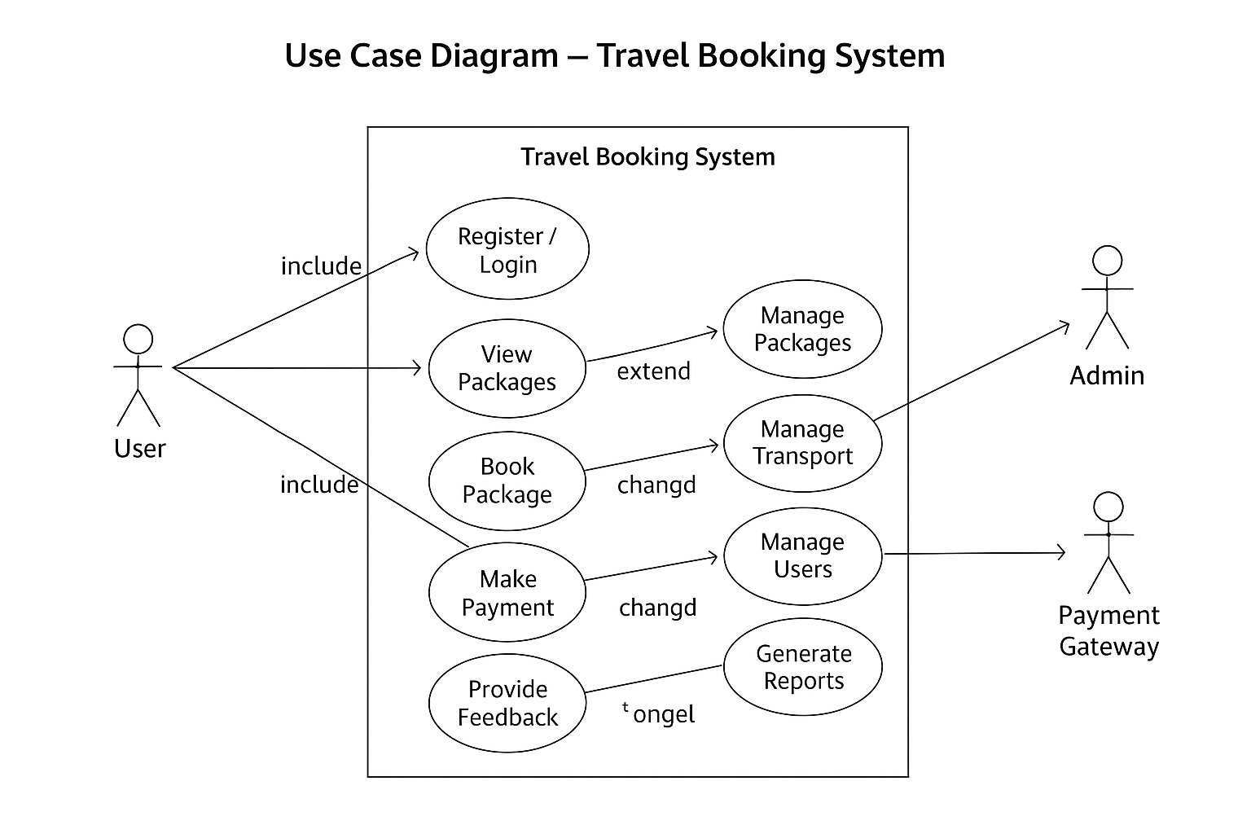**Justification:**  
This diagram provides a top-level view of system functionality and helps visualize the relationship between external entities and internal modules.

**2. Sequence Diagram**

**Purpose:**  
The Sequence Diagram models the flow of messages and interactions between objects over time. It shows how processes operate and communicate in a step-by-step manner.

**Context:**  
In the Travel Booking System, the main objects are:

* **User Interface (UI Layer)**
* **Controller (Django Views)**
* **Database Handler (Oracle Integration)**
* **Payment Module**
* **Booking Confirmation System**

**Flow Description:**

1. The user initiates a login request.
2. The controller verifies credentials from the database.
3. The user browses available packages and selects one.
4. The controller processes the booking and interacts with the Oracle DB.
5. The system verifies payment and updates records.
6. A confirmation message and receipt are sent back to the user.

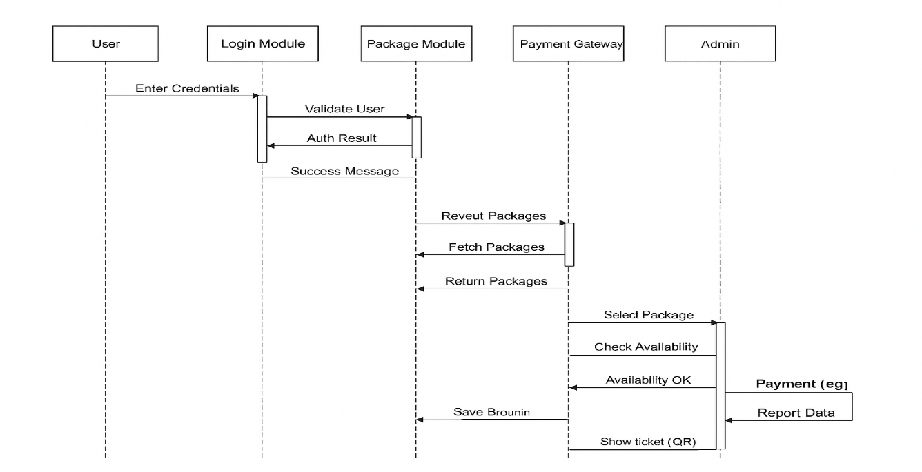**Justification:**  
This diagram is ideal for understanding the internal communication between various system components and the sequential flow of data in the standalone setup.

**3. Activity Diagram**

**Purpose:**  
The Activity Diagram depicts the workflow of the system — showing how control passes from one activity to another. It’s particularly useful for visualizing dynamic aspects such as user actions and system responses.

**Context:**  
The main flow begins with the user login process and extends through browsing, booking, and payment. Each decision or process is represented as an activity node.

**Flow Description:**

1. Start → User logs in.
2. System validates credentials.
3. If valid, the user proceeds to browse available packages.
4. The user selects a package and books it.
5. The system checks availability and confirms booking.
6. Payment is processed (simulated locally).
7. Confirmation and receipt are generated → End.

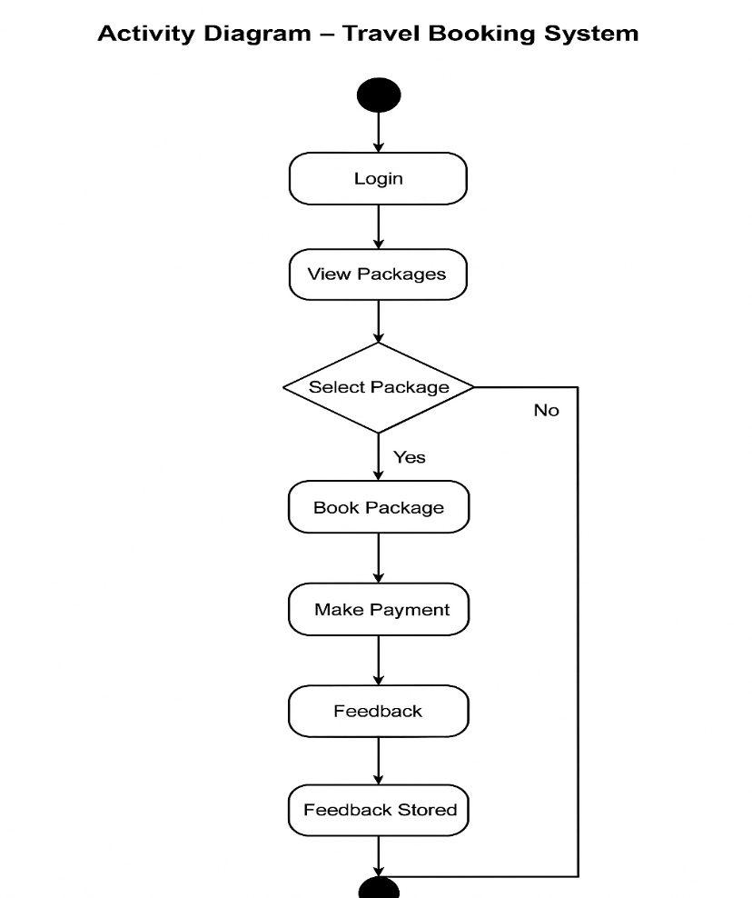**Justification:**  
It effectively represents the functional flow from the start of a session to completion of booking, highlighting decision points and control paths.

**4. State Chart Diagram**

**Purpose:**  
The State Chart Diagram defines how an entity (in this case, a **booking**) transitions through various states during its lifecycle.

**Context:**  
In the Travel Booking System, a booking can exist in multiple states based on user and admin actions.

**Flow Description:**

1. **Initial State** – Booking initiated.
2. **Pending State** – Awaiting payment confirmation.
3. **Confirmed State** – Payment completed and booking approved.
4. **Cancelled State** – User or admin cancels the booking.
5. **Completed State** – Journey finished; record archived.

**Justification:**  
This diagram helps in understanding how the system reacts to events and changes, ensuring logical transitions and consistent database updates.

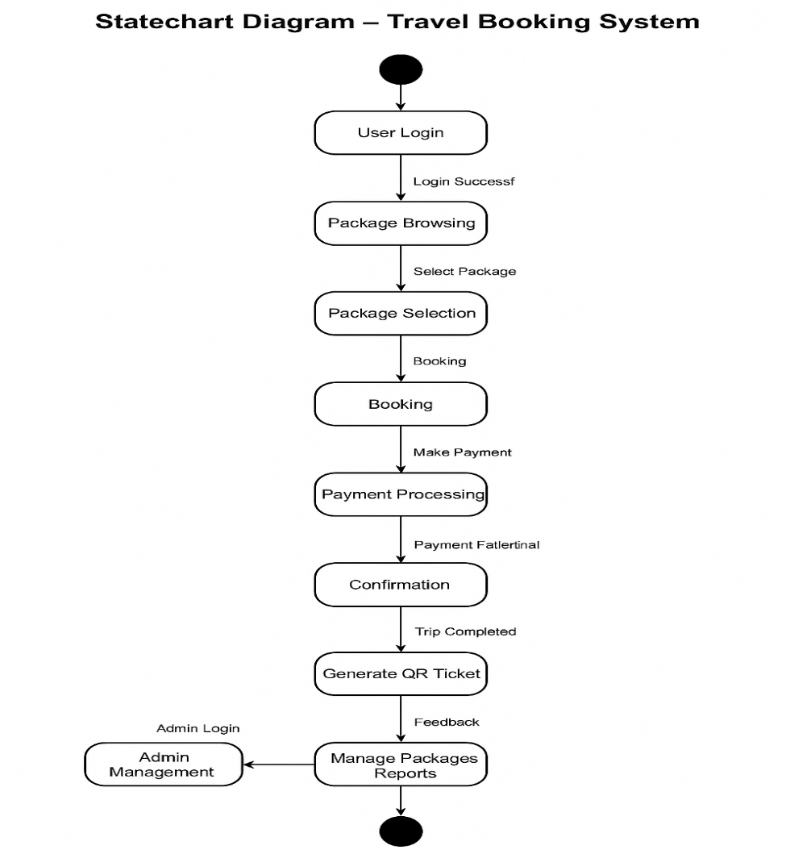

**5. Collaboration Diagram**

**Purpose:**  
The Collaboration Diagram (also called a Communication Diagram) showcases how objects interact with each other through message exchanges. It emphasizes structural relationships rather than time flow.

**Context:**  
Objects like **User Interface**, **Booking Controller**, **Payment Processor**, and **Oracle Database** exchange messages to complete booking and payment tasks.

**Flow Description:**

1. The user interface sends a booking request to the controller.
2. The controller queries the database for package details.
3. Payment module verifies transaction and updates the database.
4. Confirmation message is sent back to the user.

**Justification:**  
It visually represents how different parts of the system collaborate internally, ensuring modular communication and cohesive execution.

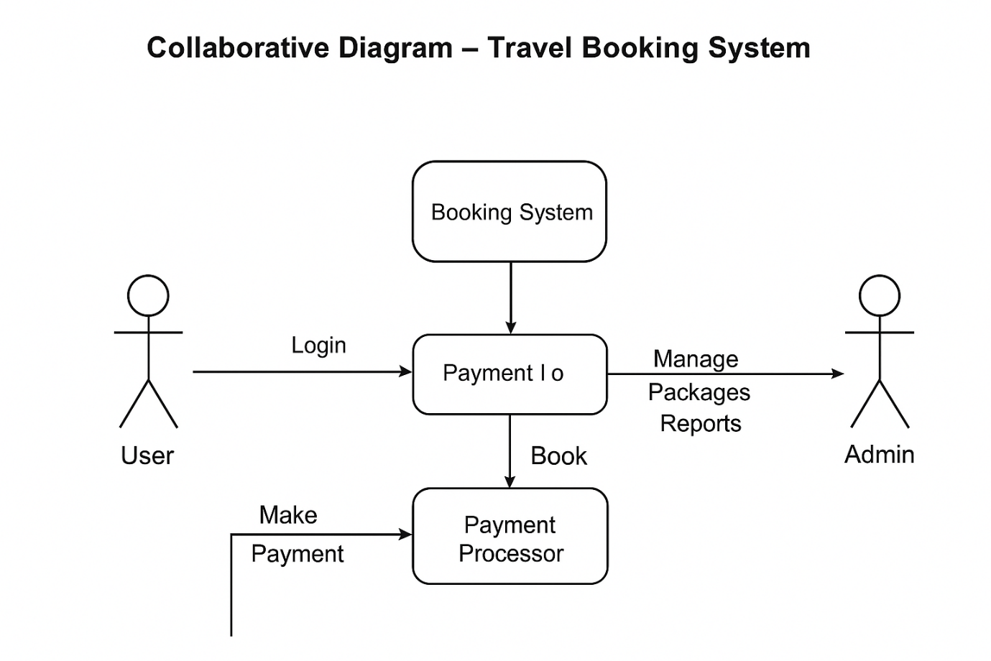

**6. Deployment Diagram**

**Purpose:**  
The Deployment Diagram describes the physical configuration of hardware and software components in the system.

**Context:**  
This standalone project runs entirely on a **single machine** with **Windows 10 Pro**, integrating Django and Oracle 11g locally.

**Flow Description:**

* The **Application Node** (Python Django Runtime) interacts with the **Database Node** (Oracle 11g).
* The **User Interface** runs on the same machine, handling input/output.
* The **Data Storage** resides in the Oracle database on the same local host.

**Justification:**  
This diagram reflects how the Travel Booking System operates as an integrated offline desktop solution without a web server dependency, ensuring fast local processing and secure data handling.

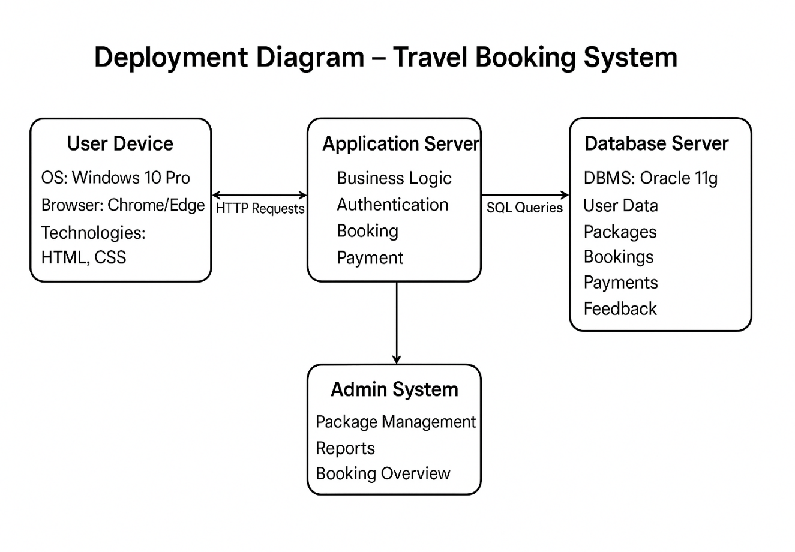

**(B). DATAFLOW DIAGRAMS (DFDs)**

**Introduction to Data Flow Diagram (DFD)**

A Data Flow Diagram (DFD) is a graphical tool used in system analysis to represent the flow of data within a system. It shows how input data is transformed into output through various processes, data stores, and external entities.  
It visually maps the movement of information and provides clarity about how the system components interact.

DFDs are divided into levels (Context Level 0, Level 1, Level 2, and so on) that represent increasing detail:

* Level 0 (Context Diagram): The highest-level view of the system, showing the system as a single process with its external entities.
* Level 1: Breaks the main process into major sub-processes.
* Level 2 & 3: Provide detailed decomposition of sub-processes to show specific data movements.

**Purpose of DFD in the Travel Booking System**

In the Travel Booking System, the DFD is used to illustrate how data moves between users, the system, and the database. It helps to understand the logical flow of activities like user registration, booking, payment, and ticket generation.

The DFDs for this project represent how:

* Customers interact with the system to book or cancel travel services.
* Admins manage travel schedules, pricing, and reports.
* The Oracle 11g database stores and retrieves relevant information like bookings, user data, and transactions.

By analyzing these diagrams, we can ensure that:

* The system’s workflow is consistent.
* Data dependencies are well-defined.
* There is no redundancy or loss of data during processing.

**Context level 0 Diagram**

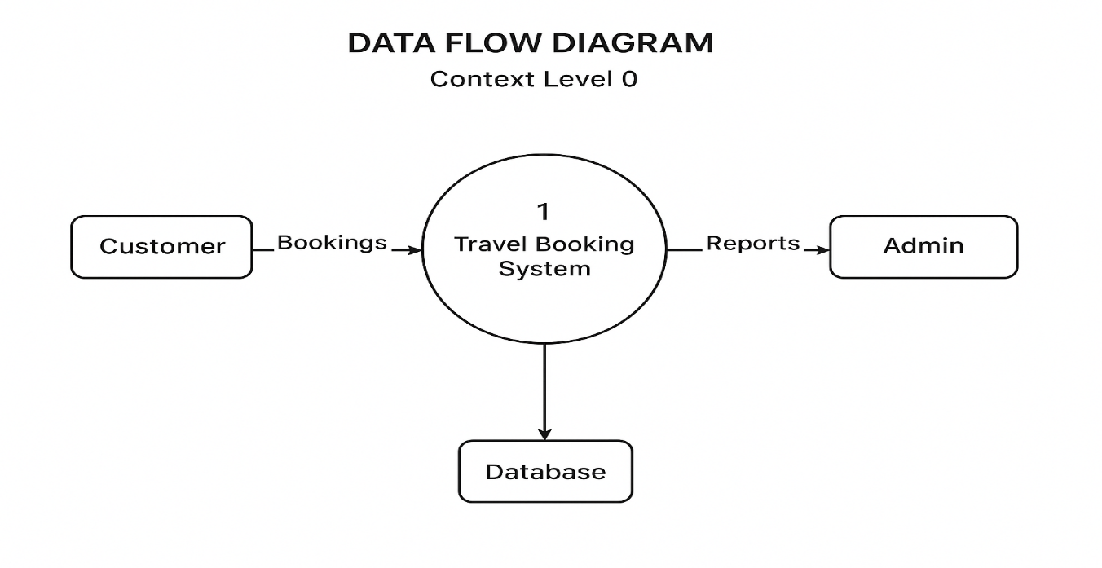

**Context level 1 Diagram**

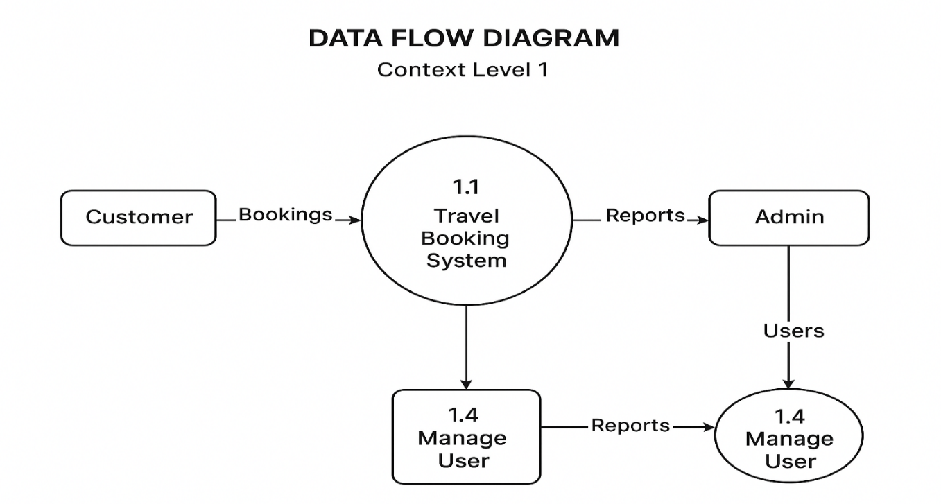

**Context level 2 Diagram**

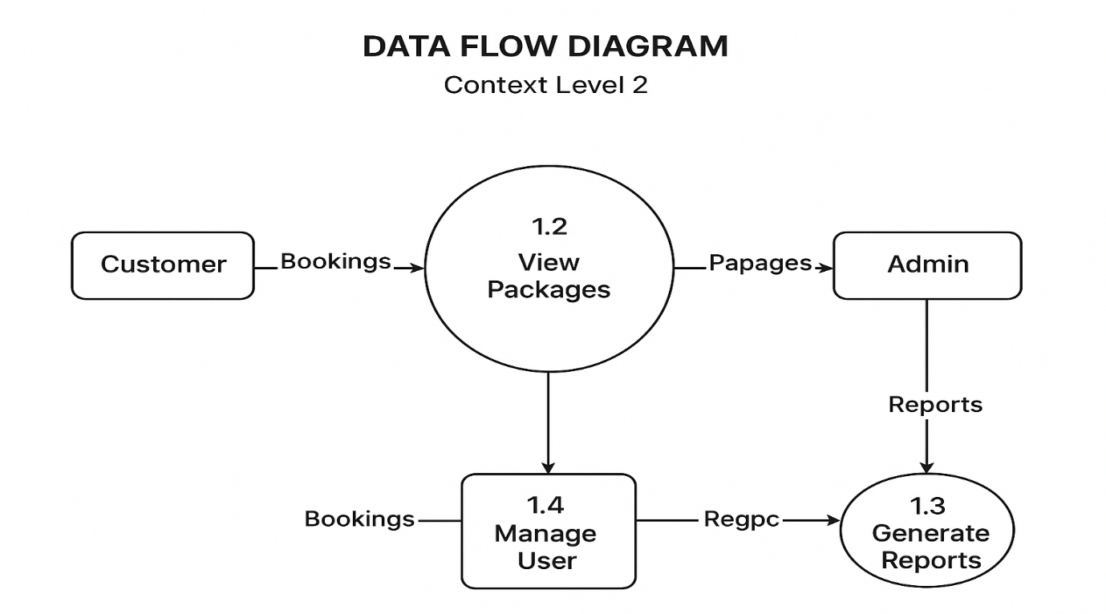

**Context level 3 Diagram**

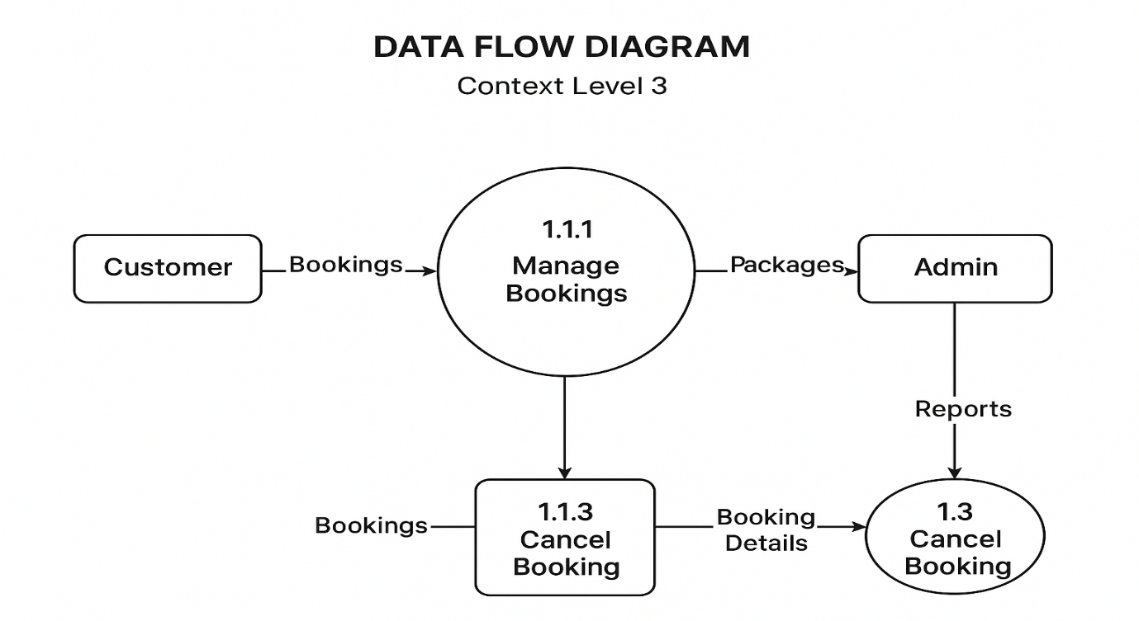

1. **DATABASE DESIGN**

**(A)DATA DICTIONARY**

A **Data Dictionary** defines the structure, format, and meaning of data elements used throughout the system.  
It acts as a bridge between the **logical design** and **physical database** by describing every table, attribute, datatype, and constraint.  
In the **Travel Booking System**, data is maintained in an **Oracle 11g relational database** integrated with the Django backend.  
The data dictionary ensures data consistency, integrity, and security across all system modules.

## **Overview**

|  |  |
| --- | --- |
| **Category** | **Description** |
| **Database Name** | Travel_Booking_DB |
| **Platform** | Oracle 11g |
| **Access Method** | Django ORM & SQL Queries |
| **Purpose** | To store, manage, and retrieve data related to users, packages, bookings, and payments in a standalone application environment |

**1.Users Table**

**Purpose:** Stores all information about users registered in the system.

|  |  |  |  |
| --- | --- | --- | --- |
| **Field Name** | **Data Type** | **Constraints / Keys** | **Description** |
| user_id | INT | PRIMARY KEY, AUTO_INCREMENT | Unique identifier for each user in the system |
| Name | VARCHAR (100) | NOT NULL | Full name of the user |
| Email | VARCHAR  (100) | UNIQUE, NOT NULL | Email address used for login and communication |
| Password | VARCHAR (255) | NOT NULL | Hashed password for user authentication |
| Phone | VARCHAR  (15) | Optional | Contact number of the user |

**2. Packages Table**

**Purpose:** Stores details of travel packages available in the system.

|  |  |  |  |
| --- | --- | --- | --- |
| **Field Name** | **Data Type** | **Constraints / Keys** | **Description** |
| package_id | INT | PRIMARY KEY, AUTO_INCREMENT | Unique identifier for each travel package |
| Title | VARCHAR (150) | NOT NULL | Name/title of the travel package |
| description | TEXT | Optional | Detailed description of the package |
| Price | DECIMAL  (10,2) | NOT NULL | Cost of the package in local currency |
| duration | VARCHAR (50) | Optional | Duration of travel (e.g., 5 days 4 nights) |
| destination | VARCHAR (100) | Optional | Location of the travel package |
| available_seats | INT | DEFAULT 0 | Number of seats available for booking |

**3.Bookings Table**

**Purpose:** Stores booking details made by users for specific packages.

|  |  |  |  |
| --- | --- | --- | --- |
| **Field Name** | **Data Type** | **Constraints / Keys** | **Description** |
| booking_id | INT | PRIMARY KEY, AUTO_INCREMENT | Unique identifier for each booking |
| user_id | INT | FOREIGN KEY → Users(user_id) | User who made the booking |
| package_id | INT | FOREIGN KEY → Packages(package_id) | Package being booked |
| booking_date | DATE | Optional | Date when the booking was made |
| travel_date | DATE | Optional | Planned date of travel |
| Status | VARCHAR (20) | Optional | Booking status (e.g., Confirmed, Cancelled) |

**4.Payments Table**

**Purpose:** Stores all payment transactions related to bookings.

|  |  |  |  |
| --- | --- | --- | --- |
| **Field Name** | **Data Type** | **Constraints / Keys** | **Description** |
| payment_id | INT | PRIMARY KEY, AUTO_INCREMENT | Unique identifier for each payment |
| booking_id | INT | FOREIGN KEY → Bookings(booking_id) | Booking associated with the payment |
| amount | DECIMAL  (10,2) | Optional | Amount paid by the user |
| Mode | VARCHAR (50) | Optional | Mode of payment (Credit Card, UPI, etc.) |
| Status | VARCHAR (20) | Optional | Status of payment (Paid, Pending, Failed) |
| transaction_id | VARCHAR  (100) | Optional | Unique transaction reference for tracking |

|  |  |  |  |  |
| --- | --- | --- | --- | --- |
|  |  |  |  |  |

**5.Reviews Table**

**Purpose:** Stores reviews and ratings provided by users for travel packages.

|  |  |  |  |
| --- | --- | --- | --- |
| **Field Name** | **Data Type** | **Constraints / Keys** | **Description** |
| review_id | INT | PRIMARY KEY, AUTO_INCREMENT | Unique identifier for each review |
| user_id | INT | FOREIGN KEY → Users(user_id) | User who submitted the review |
| package_id | INT | FOREIGN KEY → Packages(package_id) | Package being reviewed |
| Rating | INT | CHECK (rating BETWEEN 1 AND 5) | Rating given by the user (1 = lowest, 5 = highest) |
| comment | TEXT | Optional | Textual feedback about the package |

**(B)** **SQL CODE – EXECUTABLE TABLE CREATION**

CREATE DATABASE travel_booking_system;

USE travel_booking_system;

CREATE TABLE Users (

user_id INT PRIMARY KEY AUTO_INCREMENT,

name VARCHAR (100) NOT NULL,

email VARCHAR (100) UNIQUE NOT NULL,

password VARCHAR (255) NOT NULL,

phone VARCHAR (15)

);

CREATE TABLE Packages (

package_id INT PRIMARY KEY AUTO_INCREMENT,

title VARCHAR (150) NOT NULL,

description TEXT,

price DECIMAL (10,2) NOT NULL,

duration VARCHAR (50),

destination VARCHAR (100),

available_seats INT DEFAULT 0

);

CREATE TABLE Bookings (

booking_id INT PRIMARY KEY AUTO_INCREMENT,

user_id INT,

package_id INT,

booking_date DATE,

travel_date DATE,

status VARCHAR (20),

FOREIGN KEY (user_id) REFERENCES Users(user_id)

ON DELETE CASCADE ON UPDATE CASCADE,

FOREIGN KEY (package_id) REFERENCES Packages(package_id)

ON DELETE CASCADE ON UPDATE CASCADE

);

CREATE TABLE Payments (

payment_id INT PRIMARY KEY AUTO_INCREMENT,

booking_id INT,

amount DECIMAL (10,2),

mode VARCHAR (50),

status VARCHAR (20),

transaction_id VARCHAR (100),

FOREIGN KEY (booking_id) REFERENCES Bookings(booking_id)

ON DELETE CASCADE ON UPDATE CASCADE

);

CREATE TABLE Reviews (

review_id INT PRIMARY KEY AUTO_INCREMENT,

user_id INT,

package_id INT,

rating INT CHECK (rating BETWEEN 1 AND 5),

comment TEXT,

FOREIGN KEY (user_id) REFERENCES Users(user_id)

ON DELETE CASCADE ON UPDATE CASCADE,

FOREIGN KEY (package_id) REFERENCES Packages(package_id)

ON DELETE CASCADE ON UPDATE CASCADE

);